**Data Access Technologies**

No-SQL means no-sql database schema.

Schema means the structure to build a database.

Retrieving Data form database:

* ADO.NET provides

1. SQL Client – System.Data.SqlClient
2. OleDb - System.Data.OleDb
3. Odbc - System.Data.Ddbe
4. Oracle - System.Data.OracleClient
5. SQL Ce - System.Data.SqlServerCe

* ADE,NET Entity Framework

1. Entity Client - System.Data.EntityClient

* LINQ to SQL

**System.Data.SqlClient** is a namespace which connect with SQL server.

**OLE DB** (Object Linking and Embedding, Database, sometimes written as **OLEDB** or **OLE-DB**), an API designed by Microsoft, allows accessing data from a variety of sources in a uniform manner. The API provides a set of interfaces implemented using the Component Object Model (COM); it is otherwise unrelated to OLE.

oleDb connect with my access.

Demo:

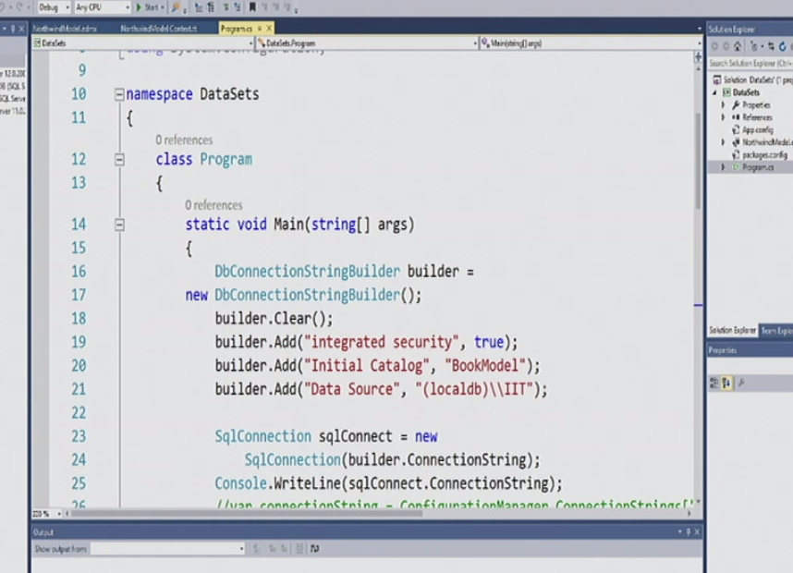

Database: BookModel

Server: IIT

**Entity Framework & LINQ**

Table of Contents

* Getting started
* Model creation / DBContext deep dive
* LINQ
* Loading strategies
* EF 6 & 6.1 New Features
* Async & Save
* Code-Base Configuration
* Connection Management
* Modification detection
* Transactions
* Code first strategies
* T4 templates and mapping
* Performance (needs updated)
* Testing and logging

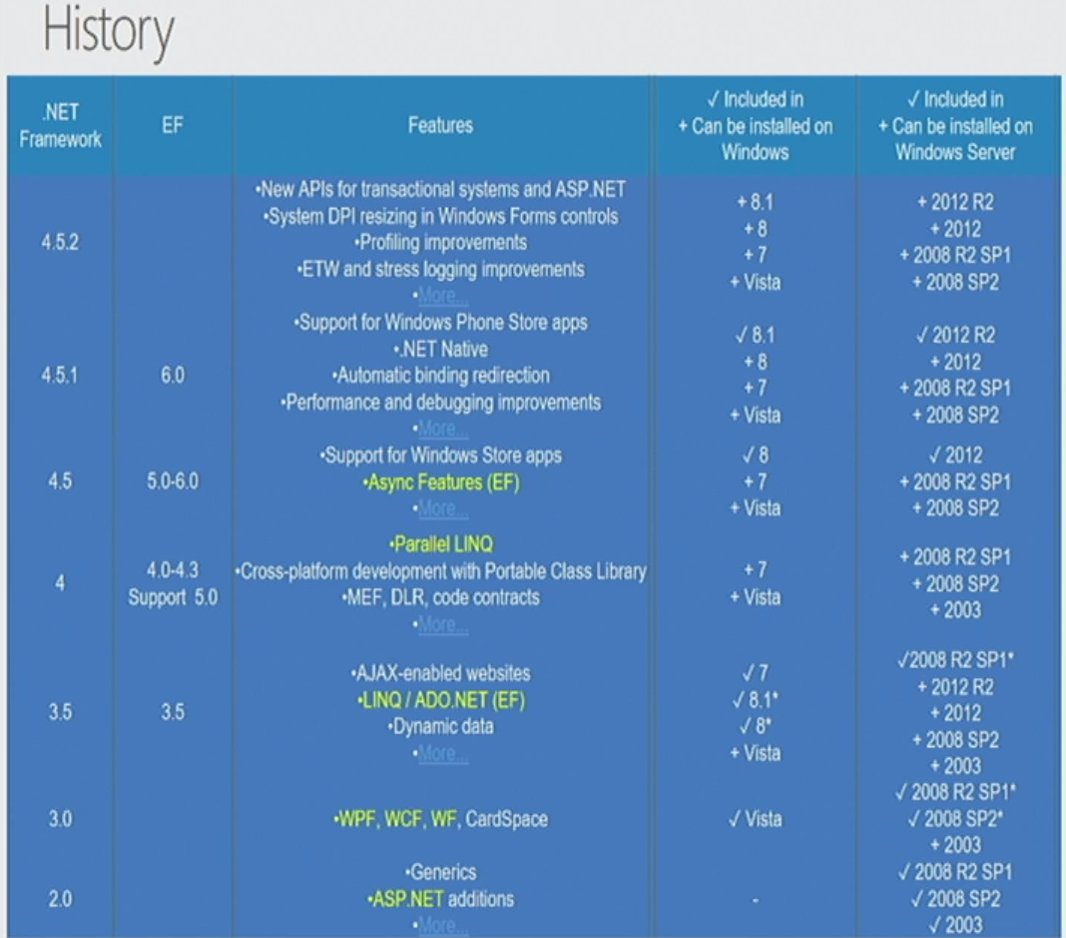

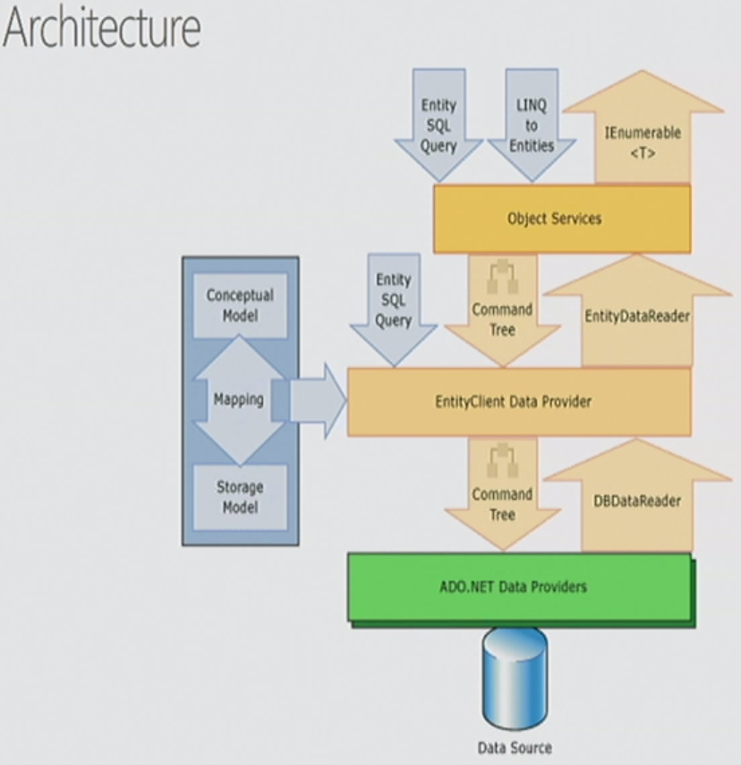

Map Files – Entity Framework

* CSDL

1. Conceptual Schema Definition Language
2. User-define Funcitons

* SSDL

1. Storage Schema Definition Language

* MSL

1. Mapping Schema Language

Map Files

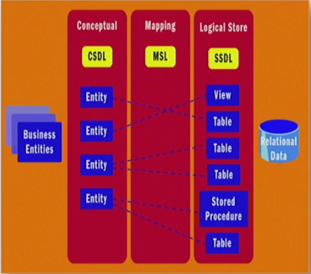

<https://share.axure.com/> give educational license to try free trial.

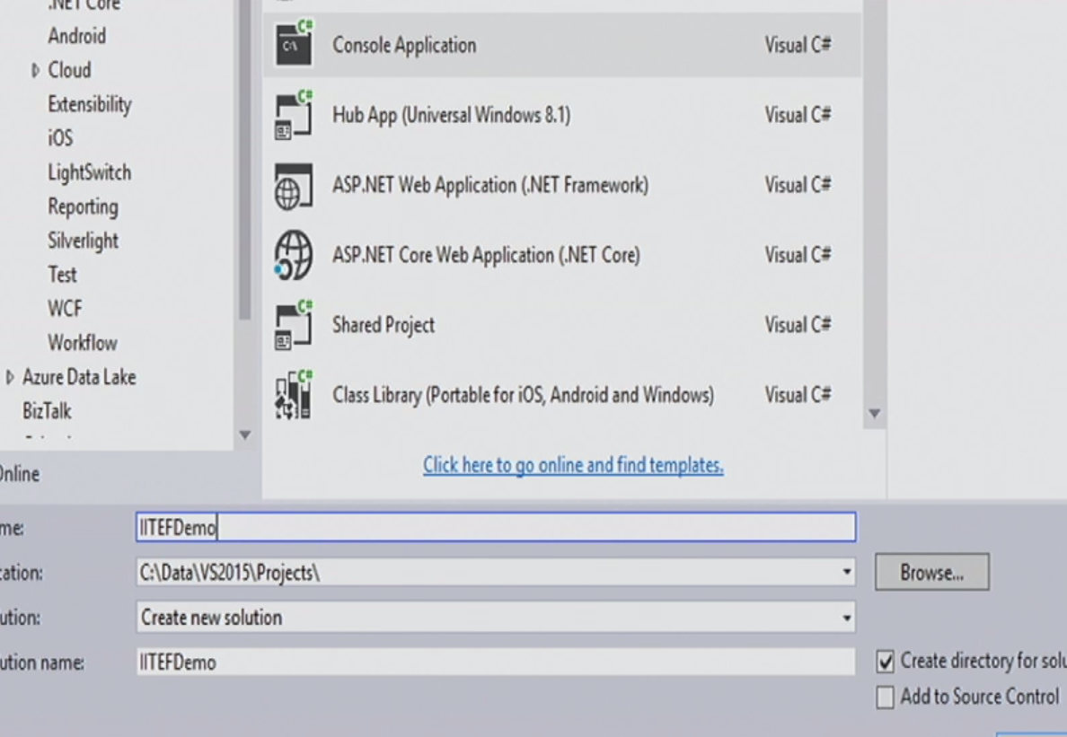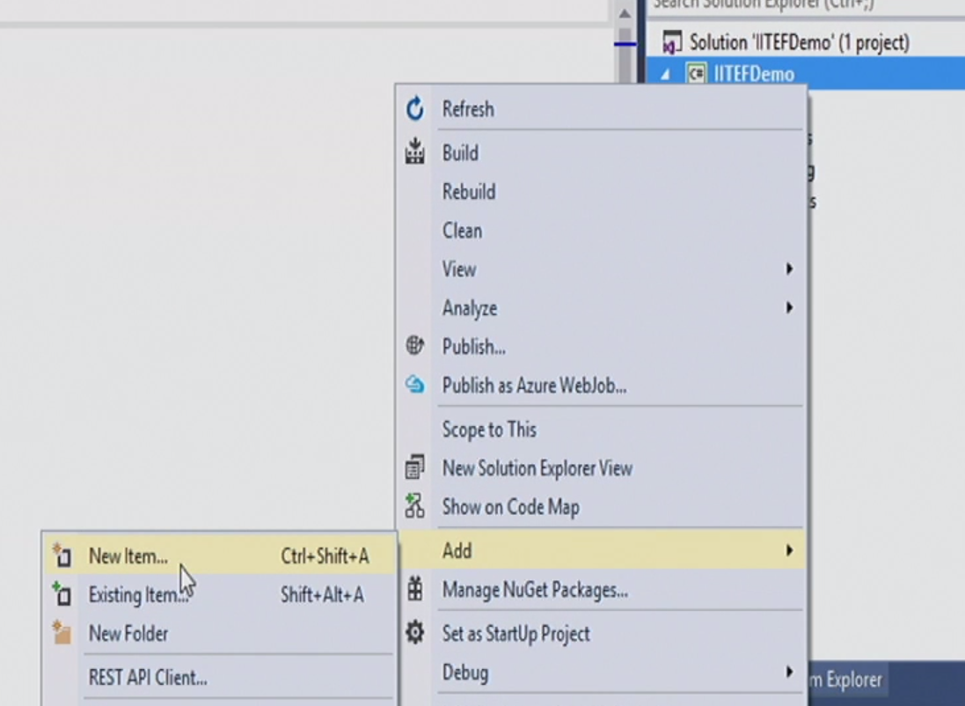

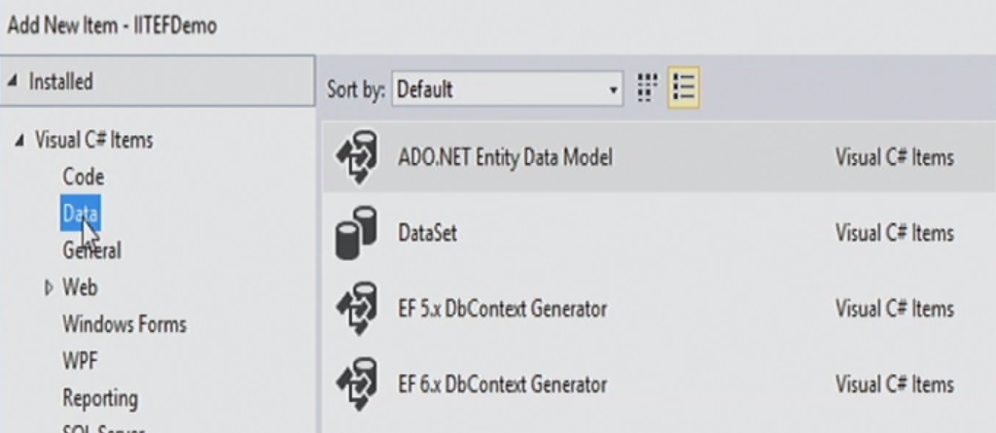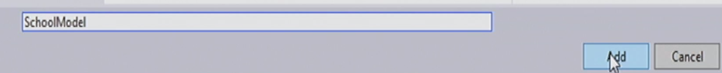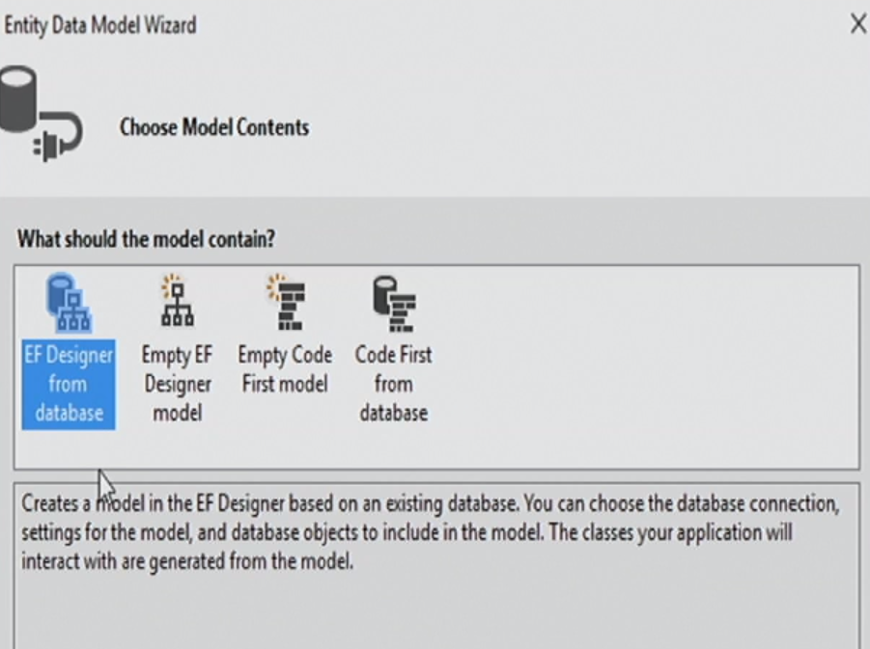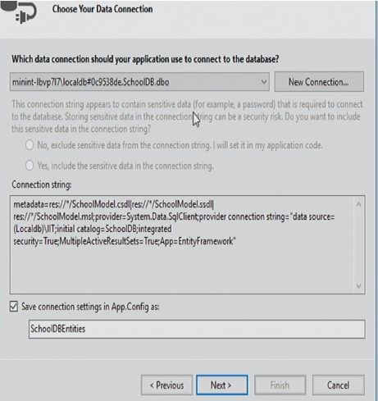

New connection

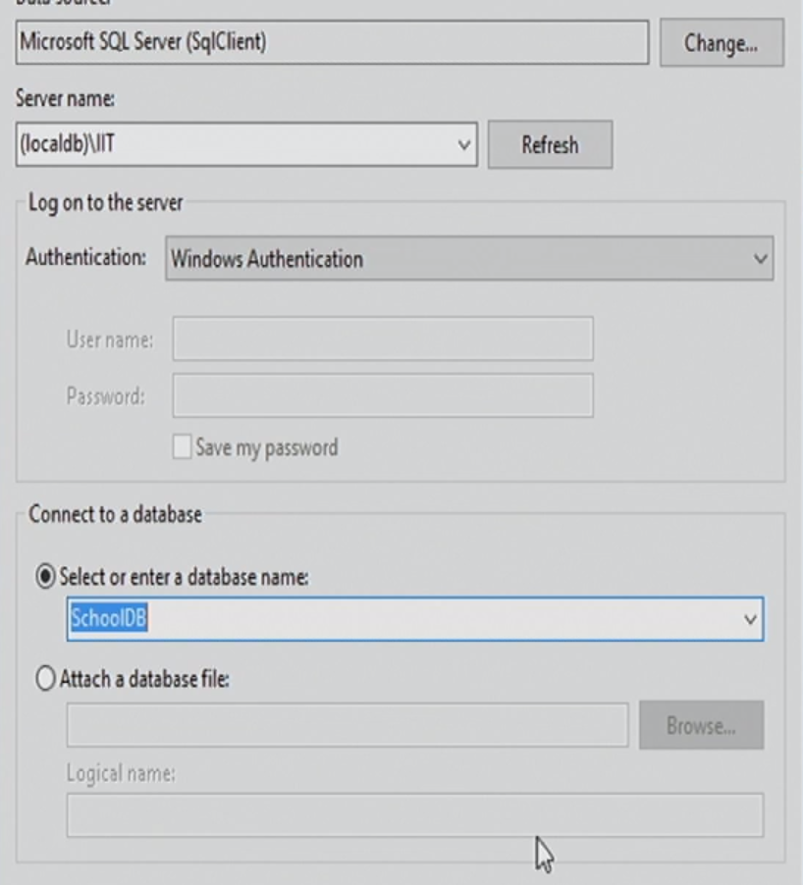

Use localdb and the exited database

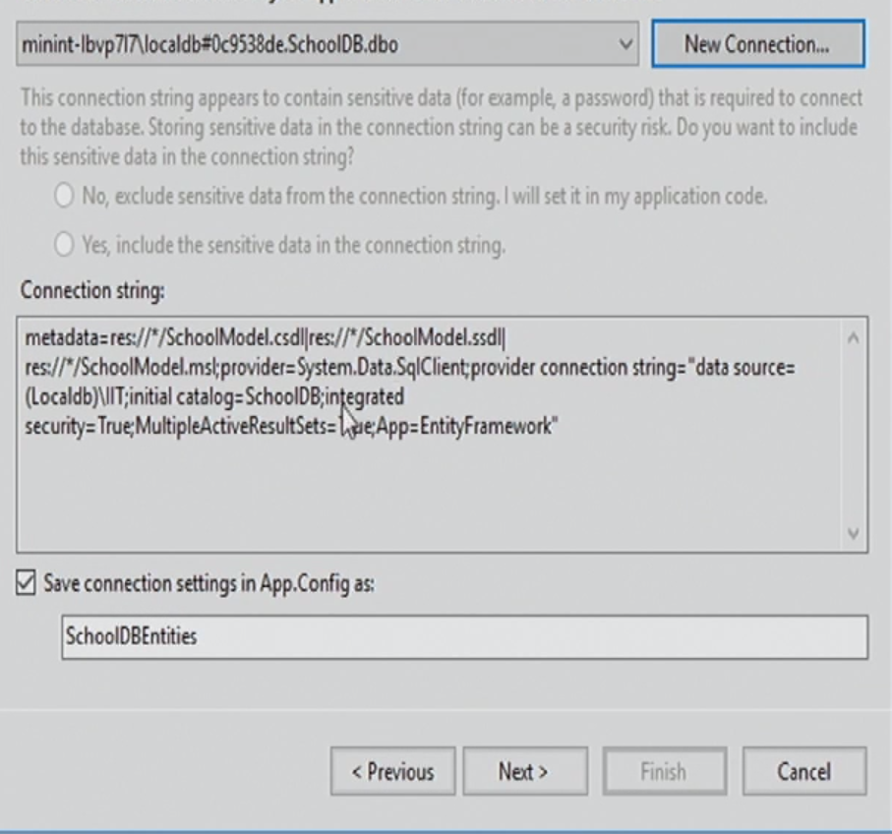

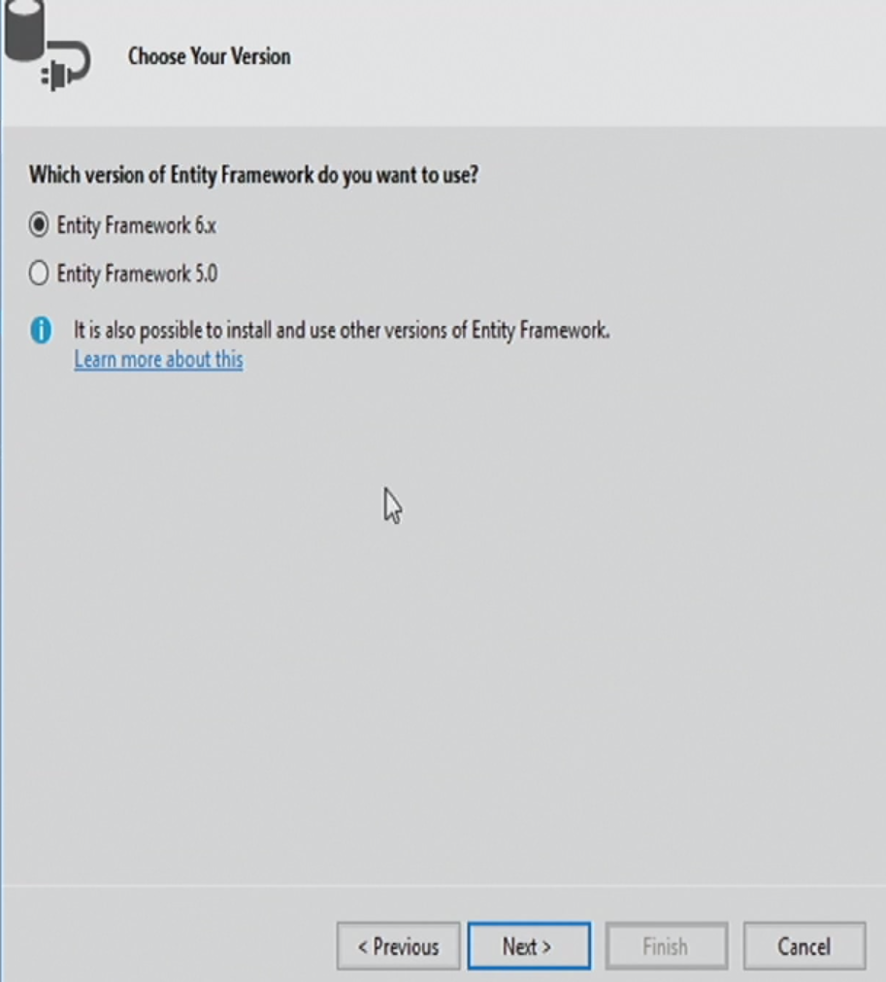

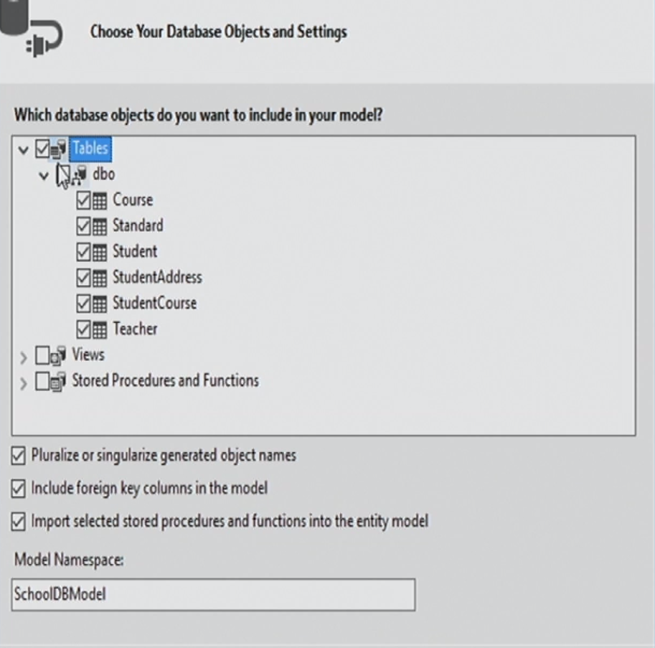

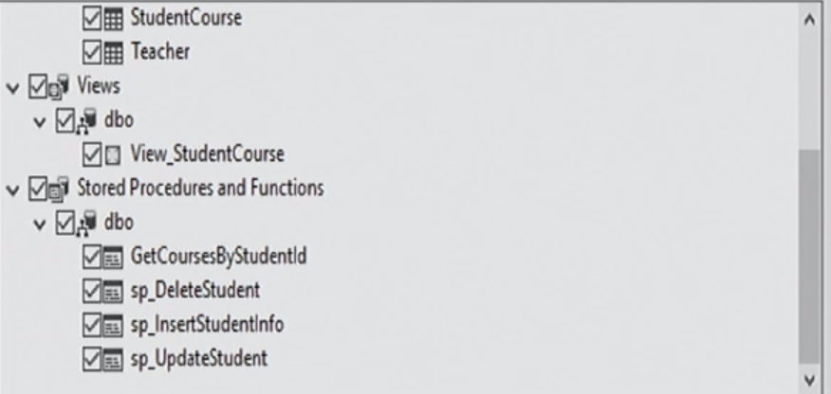

Choose everything and finish.

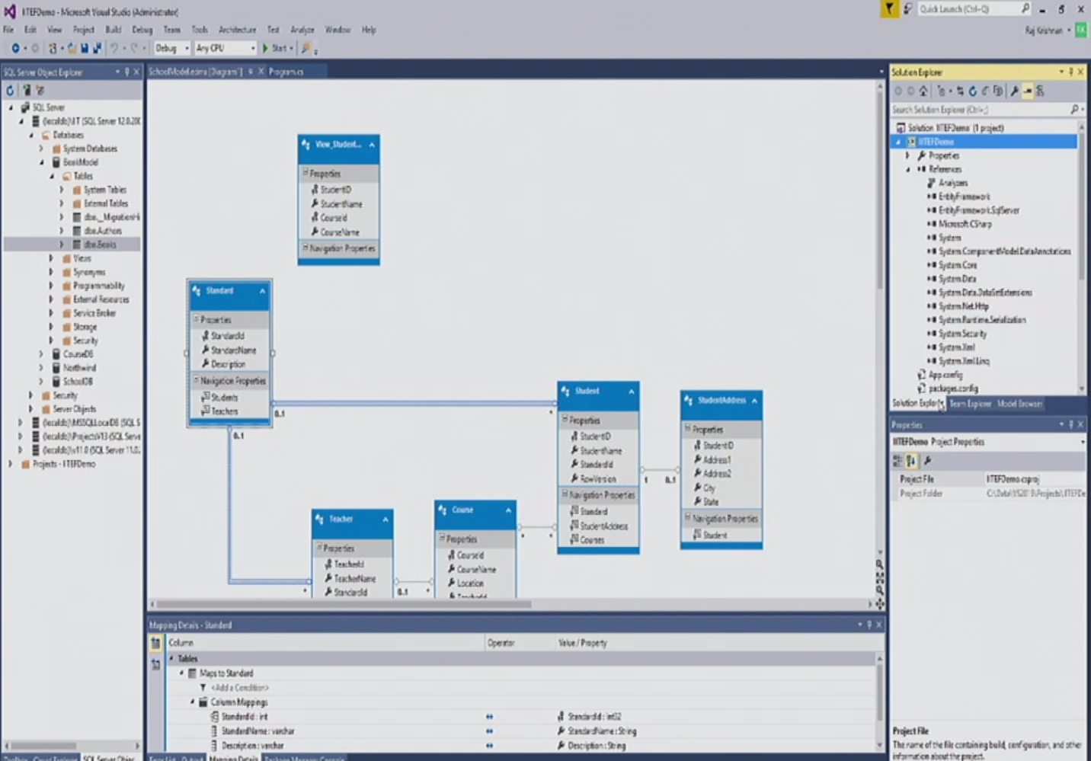

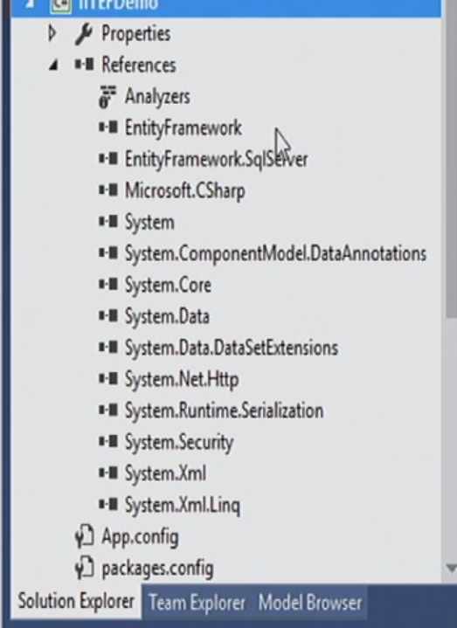

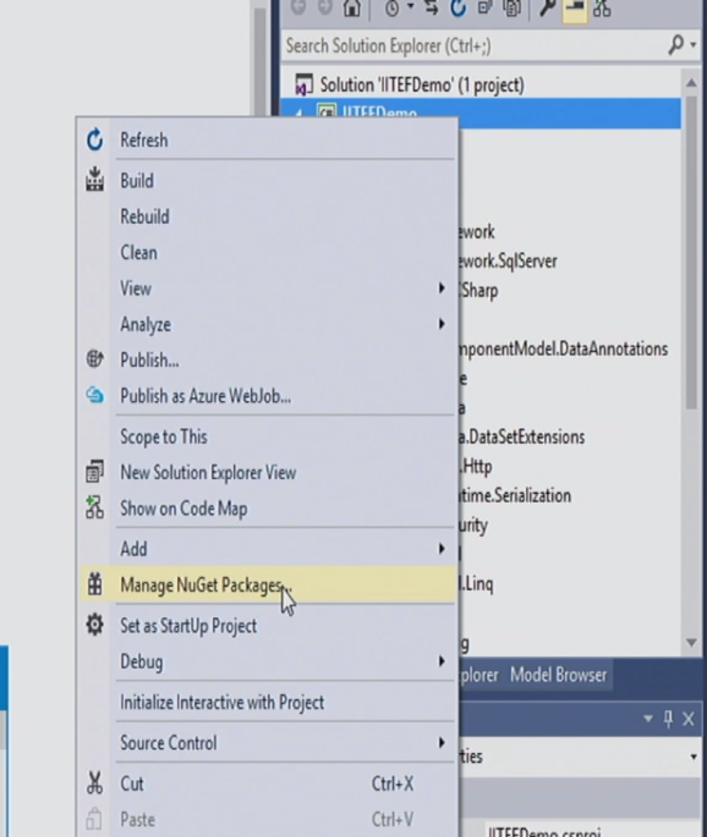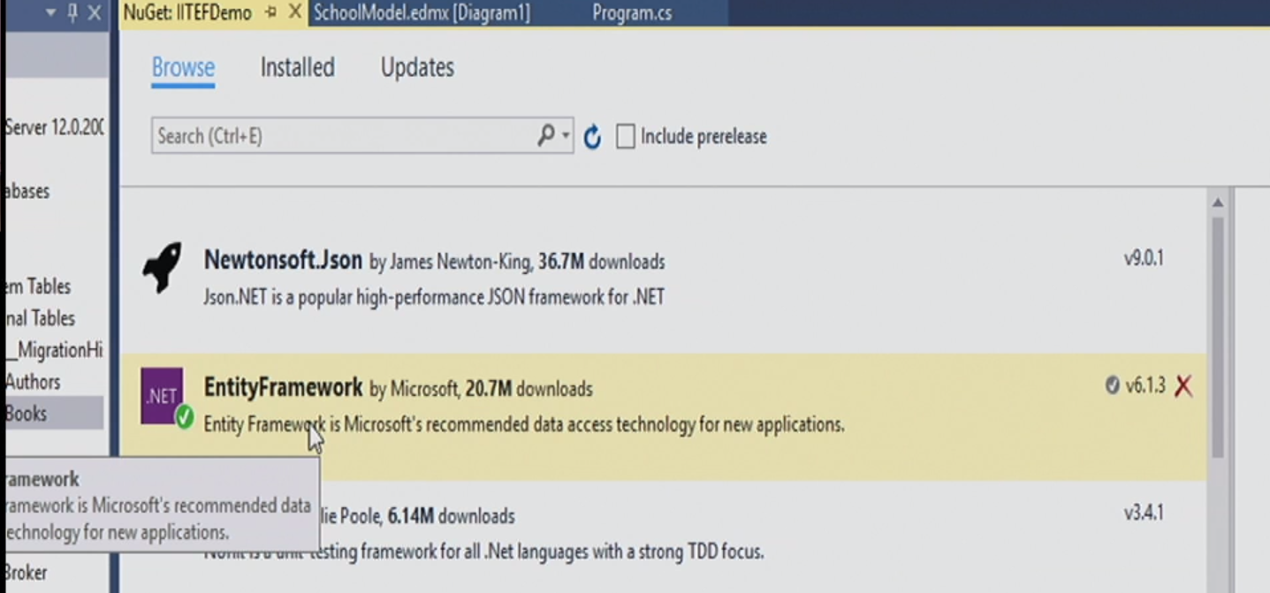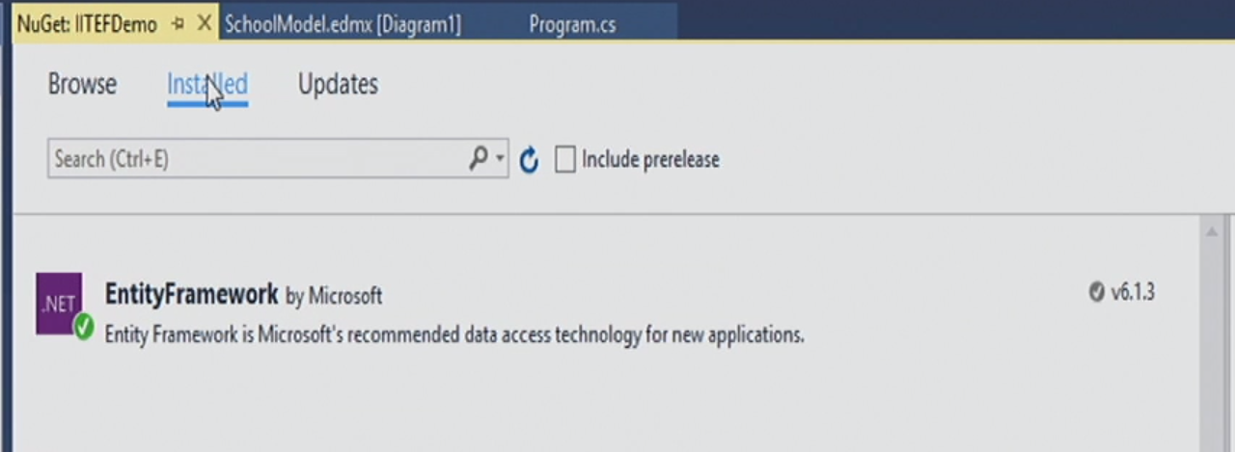

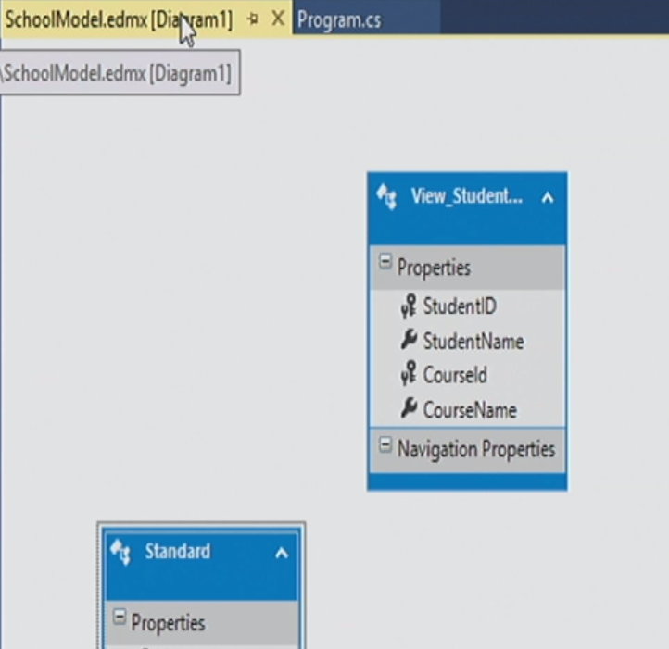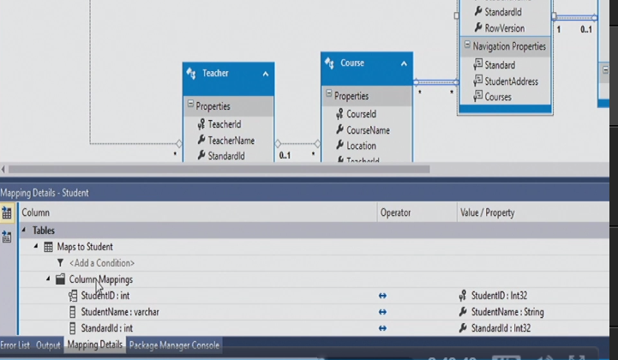

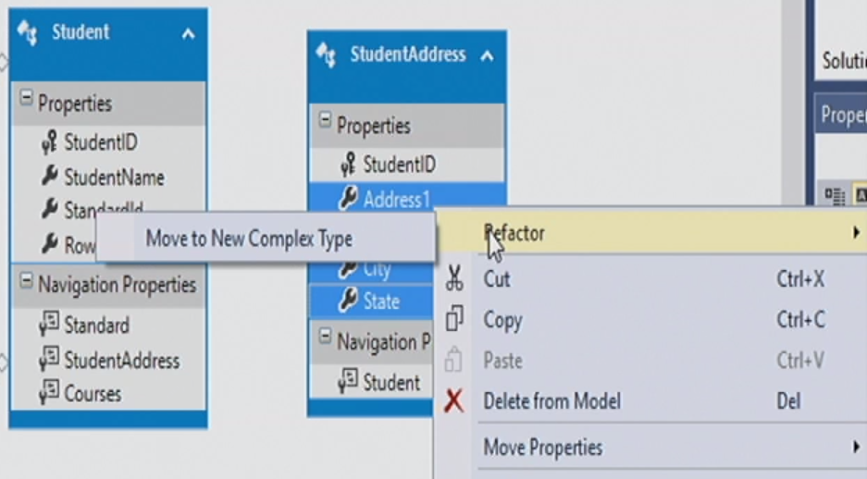

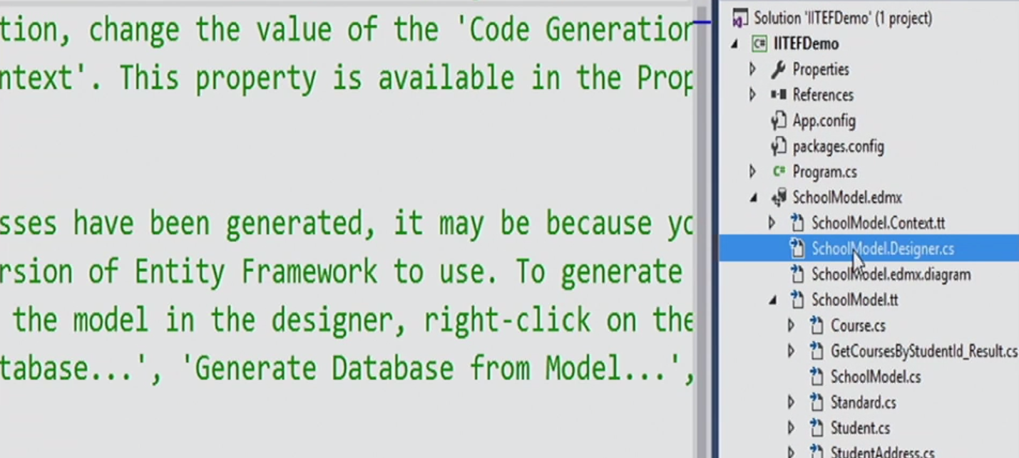

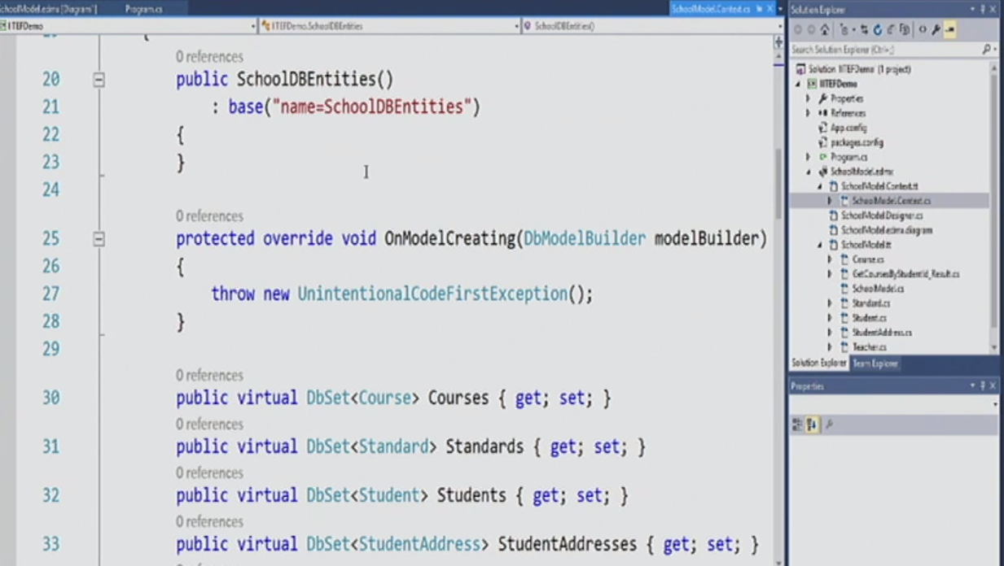

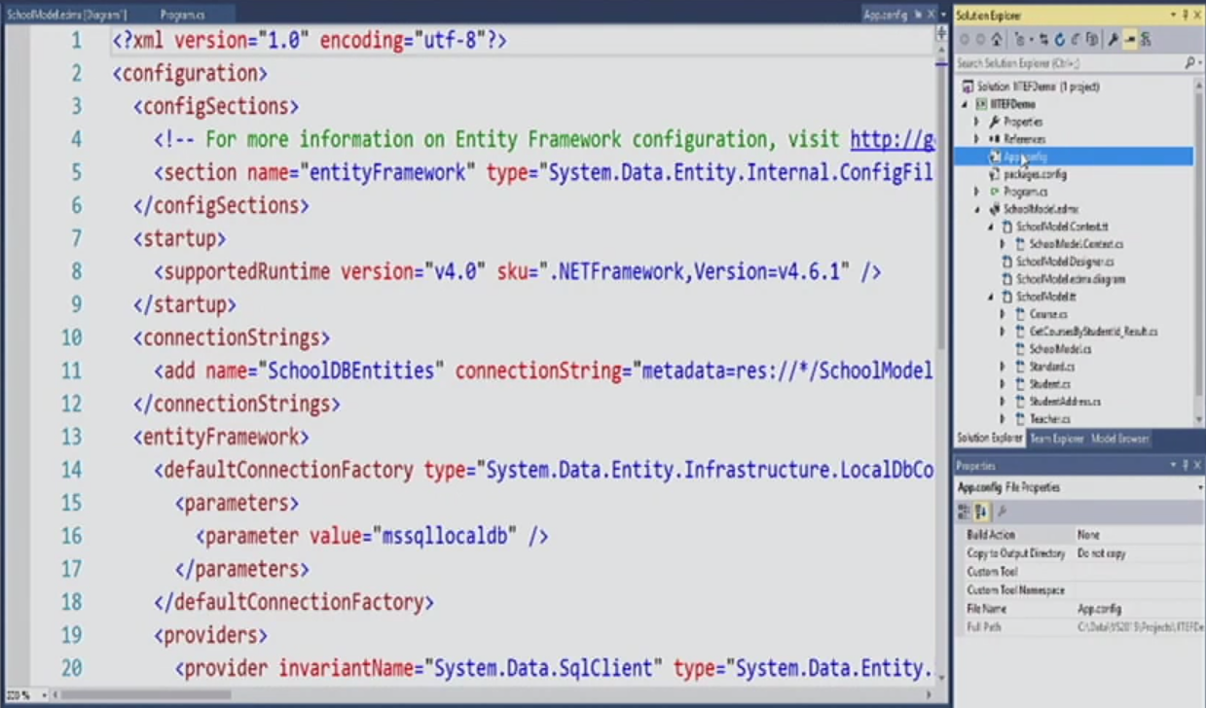

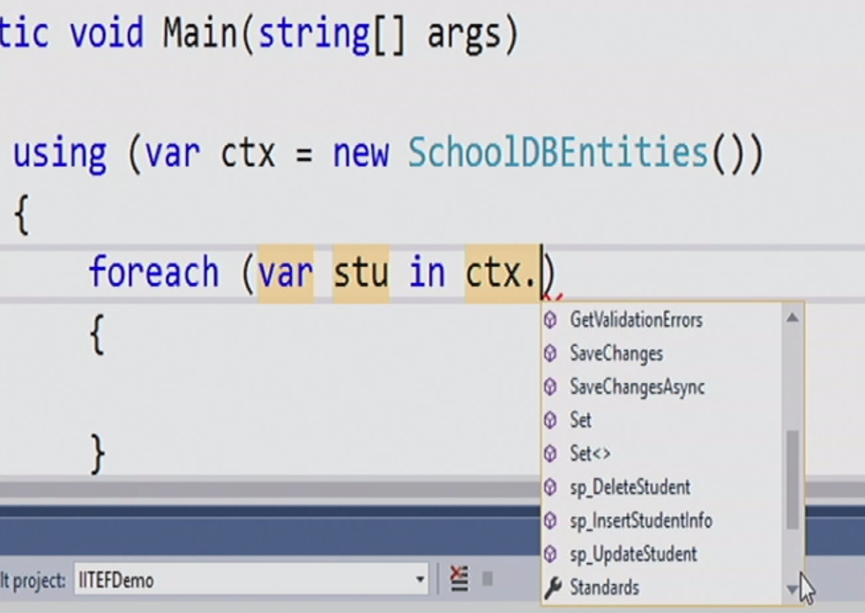

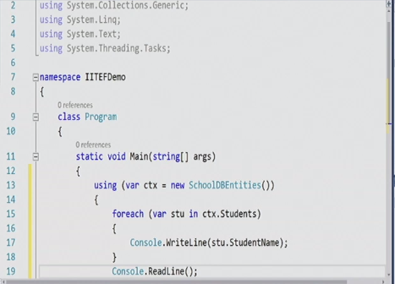

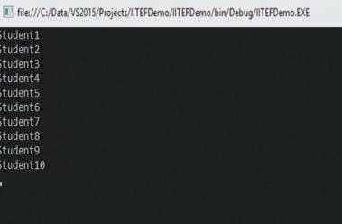

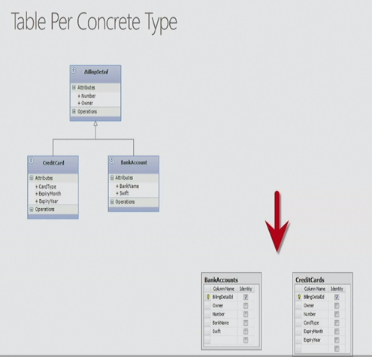 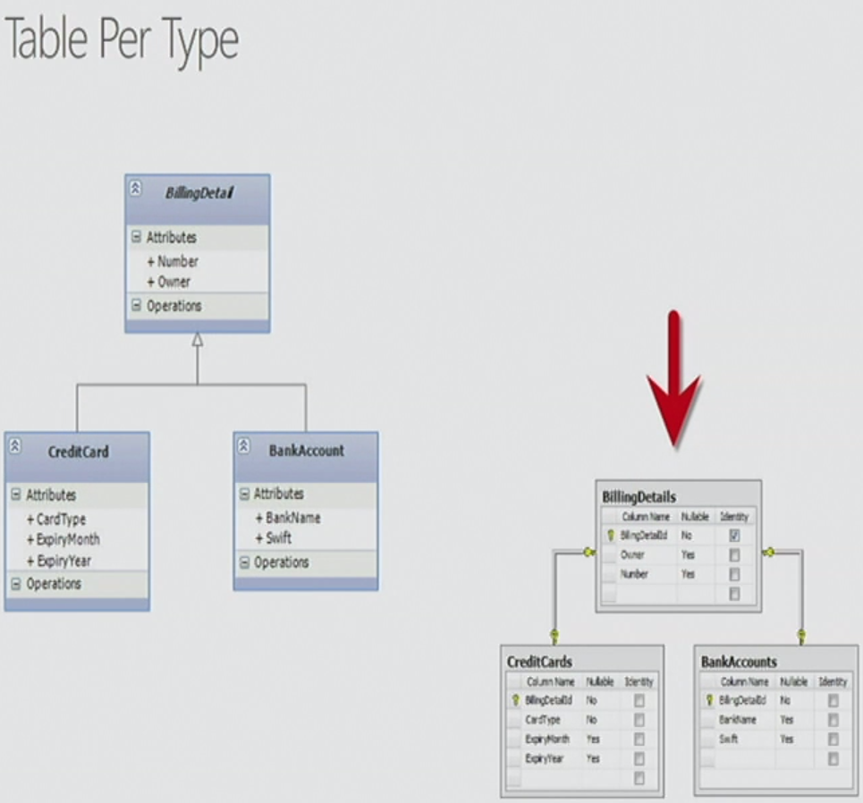

The second one type is bad design

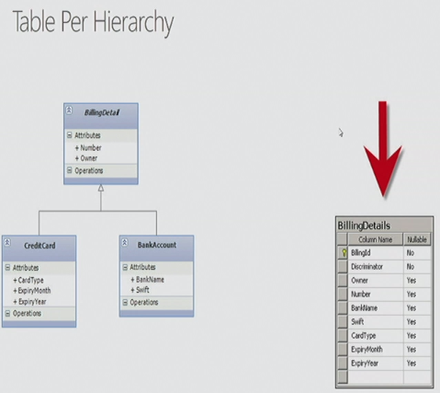

Creation Strategies:

DB & Model Creation

* Model-First/Top-down approach

1. Create database from entities/EF model
2. Create/drops the database, doesn’t modify
3. Designer -> Generate Database Script from Model
4. Execute the DDL separately SSMS

* Database-First/Bottom-up approach

1. Create Entities from database. Designer doesn’t support TPC, uses TPT default.

* Code first

